 | 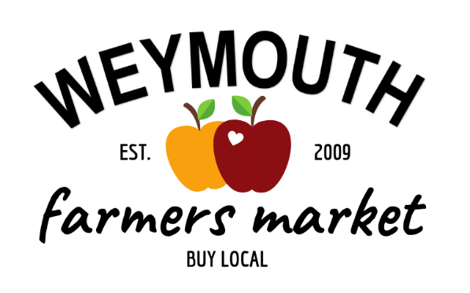 | Weymouth Town Hall  75 Middle Street  Weymouth, MA 02189  (781) 340-5012  www.weymouth.ma.us/farmers-market

2020 VENDOR APPLICATION TO
SELL AT THE WEYMOUTH FARMER'S MARKET

Farm/Business:
Contact Person:
Mailing Address:
Farm/Business
Address (if different):

Phone: Cell/Other:
Email: Fax:
Website:

Inventory list of products to be sold at the Farmer’s Market: (check all that apply)
Vegetables:
Asparagus | Beans – Green | Beans – String | Beans – Wax | Beets
Broccoli | Cabbage | Carrots | Cauliflower | Celery
Corn | Cucumbers | Eggplant | Greens – Collard | Greens – Mustard
Greens – Turnip | Kale | Kohlrabi | Lettuce – Boston | Lettuce – Romaine
Lettuce – Red Leaf | Onion – Yellow | Peas | Peppers – Green | Peppers – Hot
Potatoes – White | Potatoes – Sweet | Pumpkins | Radishes | Scallions
Spinach | Squash – Summer | Squash – Winter | Squash – Zucchini | Tomatoes – Green
Tomatoes – Vine Ripe | Turnip
Other vegetables:

Fruits, Berries and Melons:
Apples | Blackberries | Blueberries | Cantaloupe | Nectarines
Peaches | Pears | Plums | Raspberries | Strawberries
Watermelons
Other fruits, berries or melons:

Herbs:
Basil | Mint | Oregano | Parsley | Rosemary | Sage
Other herbs:

Plants & Flowers
Bedding Plants | Cut Flowers | Hanging Plants | Mums | Wild Flowers
Other plants, flower or ornamental crops:

Eggs, Milk and Dairy Products:
Cheese | Eggs | Milk
Other dairy products:

Processed Foods and Drinks:
Cider | Coffee | Honey | Jam | Jelly
Juice | Maple Syrup
Other processed foods and drinks:

Baked Goods (specify):

Meats (specify):

Seafood (specify):

Non-Food or Plant Products (specify):

Vendor Types and Fees (choose one)
Food Vendors - $100 full season
Non-food vendors – $150 full season
Weymouth resident home gardeners – free with proof of residency
If participating at a promotional rate, indicate the full season cost here:
Promotional rate approved by: (for office use only)
Please make checks payable to “Town of Weymouth”
All fees must be paid prior to participating in the Farmer’s Market.

WEYMOUTH FARMER'S MARKET VENDOR AFFIDAVIT

I/We
(Contact Person Name and Farm/Business Name)

hereby agree to sell or offer for sale at the Weymouth Farmer’s Market only such items which are of my/our own production and which are listed within this application. I/We attest that all information provided in this application is complete and correct to the best of my/our knowledge. I/We hereby have read, understand and agree to abide by the Weymouth Famer’s Market Rules & Regulations. I/We further acknowledge full responsibility for all my/our activities conducted during operation at the Farmer’s Market and agree to hold the Town of Weymouth, the Massachusetts Department of Food and Agriculture, and any sponsoring agency harmless and to indemnify said agencies, the Farmer’s Market Steering Committee, Market Manager and/or other Steering Committee representatives from any and all claims arising under this application.

{This space intentionally left blank.}

All Vendors are encouraged to have and are responsible for their own product and liability insurance. Please choose one of the following:
I have product and liability insurance. (Please attach copy of insurance agreement.)
I have been advised to get product and liability insurance but have chosen not to purchase insurance.

Name (please print)

Signature Date

Please return with payment to:

Kerry Knapp
Weymouth Farmer’s Market Committee
c/o Mayor’s Office,
Weymouth Town Hall
75 Middle Street
Weymouth, MA 02189

