TOWN OF WEYMOUTH
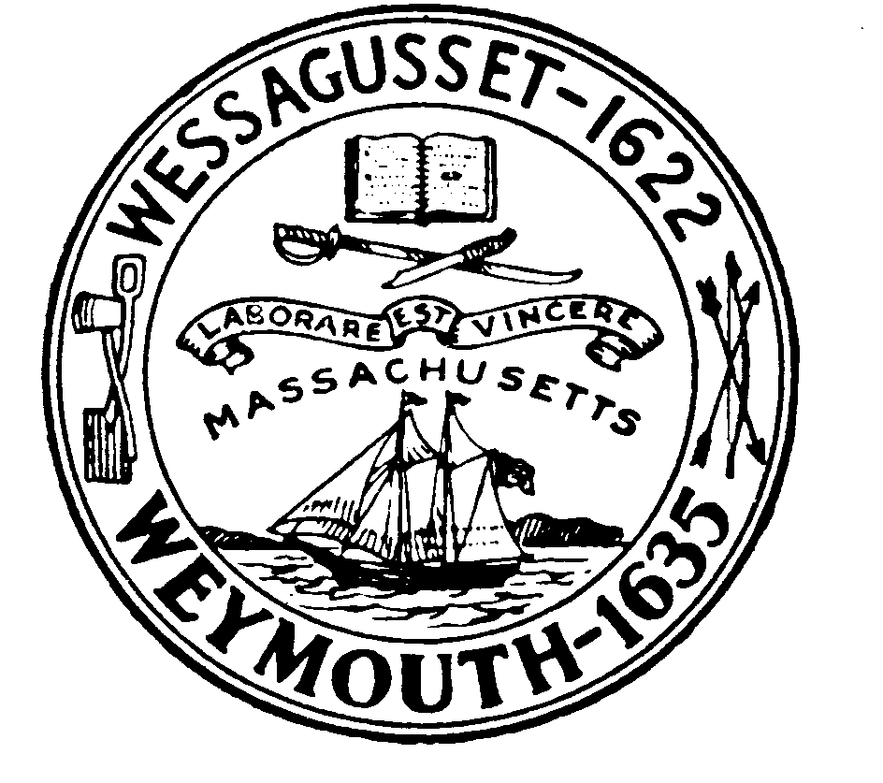

PLANNING BOARD

Notice is hereby given of a public hearing of the Planning Board of the Town of Weymouth under MGL Ch. 41, Sec. 81T and the Weymouth Subdivision Regulations to be held at:

7:00 P.M.
TUESDAY, MAY 10, 2022
MC CULLOCH BUILDING, MARY MCELROY MEETING ROOM
182 GREEN STREET
WEYMOUTH, MASSACHUSETTS

Public Hearing on the Definitive Subdivision application of Ryder Development Corporation., for property located at Edison Street & Narragansett Avenue, Weymouth, MA, also shown on the Weymouth Town Atlas Sheet 13, Block 155, Lots 17, 23, 26 & 28 and Sheet 13, Block 156, Lots 28 & 59 for a proposed subdivision shown on a plan entitled: “Definitive Subdivision of Savanna Drive in Weymouth Massachusetts” prepared by SITEC Engineering and Environmental Consultants, Inc., dated and stamped February 15, 2022. The subdivision application proposes a new road off Narragansett Ave. accessing (10) ten new buildable lots for the construction of single-family homes in the R-1 district.

The application and plans are on file at the Planning Department, Town Hall, 75 Middle, Weymouth, MA, and may be inspected between 8:30 A.M. and 4:30 P.M., Monday through Friday.

Weymouth Planning Board

Patriot Ledger Advertising Dates:

Tuesday, April 26, 2022, and Tuesday, May 3, 2022

