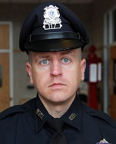
Sergeant Michael Chesna was born and raised in Weymouth, Massachusetts. After the tragedies of September 11, 2001 Mike enlisted in the U.S. Army to serve his country with the 187 10th Mountain Division. Mike served two tours of duty, where he was awarded the Purple Heart. After Mike’s time in the Army he attended and graduated from the Boylston Police Academy. Mike soon fulfilled his childhood dream of becoming a Weymouth Police Officer. Mike began his WPD watch on July 16, 2012.

