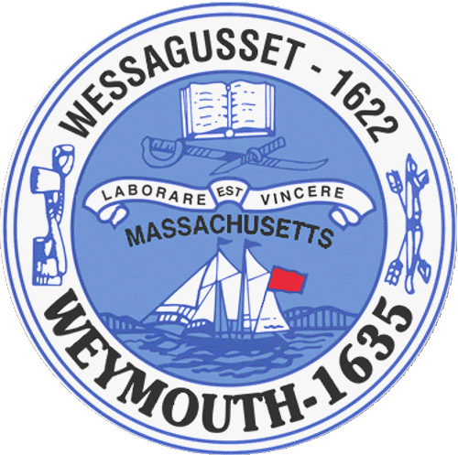

Weymouth Elder Services
Karen S. Johnston, Director
182 Green Street
Weymouth, MA 02191

AGENDA
BOARD OF ELDER SERVICES
03/21/2016

TO: All Weymouth residents and the specifically the Board of Elder Services
FROM: Karen Johnston, Director of Elder Services
RE: Quarterly, Board Meeting
DATE: 03/21/2016
WHERE: Weymouth Elder Services, 182 Green Street, Weymouth MA 02191
____________________________________________________________________________________

DIRECTOR’S REPORT:

Programs in addition to our regularly scheduled programs.

Grants
Grants to
Transportation
Building Maintenance / Improvements
Outreach
Volunteer Management
Other

NEW BUSINESS:

NEXT MEETING: June 13th at 10:00 AM at the Whipple Center

