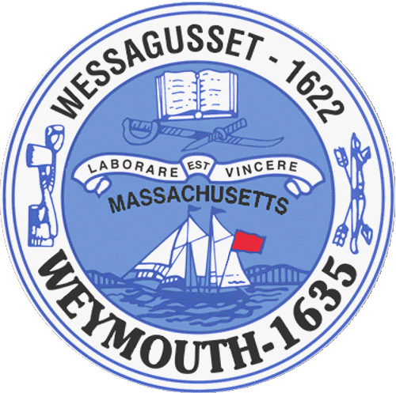

Weymouth Elder Services
Karen S. Johnston, Director
182 Green Street
Weymouth, MA 02191

AGENDA
BOARD OF ELDER SERVICES
06/19/2017
TO: All Weymouth residents and the specifically the Board of Elder Services
FROM: Karen Johnston, Director of Elder Services
RE: Quarterly, Board Meeting
DATE: 06/19/2017
WHERE: Weymouth Elder Services, 182 Green Street, Weymouth MA 02191
____________________________________________________________________________________
Agenda:

Old Business

Budget
Programs
Transportation
Outreach
Activities
Building Maintenance and Repair

New Business

Open Positions
Internships
National Council on Aging Accreditation

