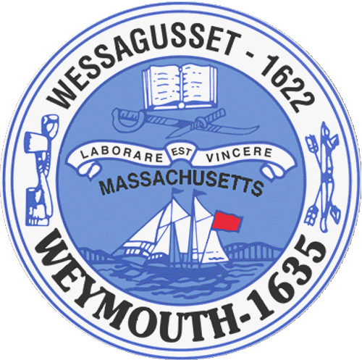

Weymouth Elder Services
Karen S. Johnston, Director
182 Green Street
Weymouth, MA 02191

AGENDA
BOARD OF ELDER SERVICES
09/18/2017
TO: All Weymouth residents and the specifically the Board of Elder Services
FROM: Karen Johnston, Director of Elder Services
RE: Quarterly, Board Meeting
DATE: 09/18/2017
WHERE: Weymouth Elder Services, 182 Green Street, Weymouth MA 02191
____________________________________________________________________________________
Agenda:

Old Business

Budget
Programs
Transportation
Outreach
Activities
Building Maintenance and Repair

New Business

Open House – October 11th, 2017 1:00 – 3:00 P.M.

