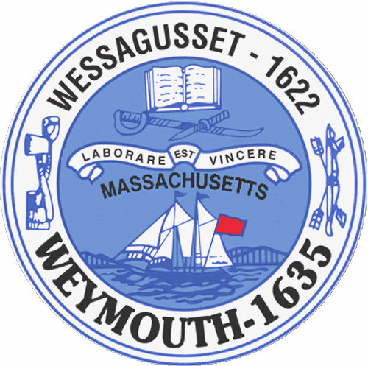

Rebecca Haugh
Thomas J. Lacey
Arthur Mathews
Brian McDonald
Michael Molisse

TOWN COUNCIL

Patrick O’Connor, President
Michael Smart, Vice President
Robert M. Conlon
Kenneth DiFazio
Jane Hackett
Ed Harrington

Town of Weymouth
Massachusetts

781-335-2000

781-331-5124 (TTY)

AGENDA

Special Town Council Meeting

May 26, 2015
7:30 PM
Council Chambers-Town Hall

- PLEDGE OF ALLEGIANCE

- ROLL CALL

- ANNOUNCEMENTS

- PUBLIC HEARINGS

7:35PM 15 076-Proposed Proposition 2 ½ Override
Continued Public Hearing from May 18, 2015

Presentation by Mayor Susan Kay and Administration
Proposed Proposition 2 ½ Override

- OLD BUSINESS

15 076 –Proposition 2 ½ Override

- REPORTS OF COMMITTEES

Budget Management Committee-Chairman Michael Molisse

15 070-Debt Refinancing

15 071-Bonding for Various Capital Projects

15 073-CDBG Authorization 2015-2016

15 079-Reappointment to the Board of Library Trustees-Dorothy Coveney

15 080-Reappointment to the Waterfront Committee-Raymond Nash

15 081-Reappointment to the Local Emergency Planning Committee-Jonathan Tose

15 082-Pensions and Benefits Line Item Transfer

15 083-RFT-Administrative Services

15 084-RFT-Fire Department Overtime

15 085-RFT-Water Enterprise Overtime

- NEW BUSINESS

Councilor at Large Robert Conlon
Proposed menu override to Proposition 2 ½ proposal

8. ADJOURNMENT

