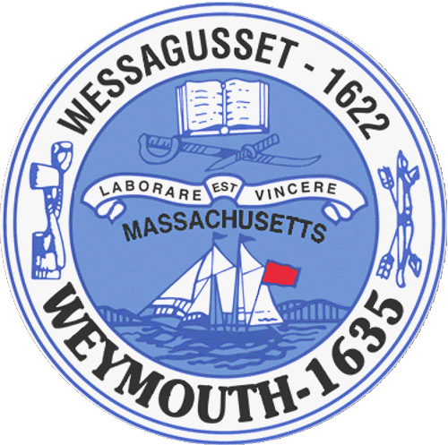

ANNUAL TOWN MEETING
PURSUANT TO SECTION 6-6A OF THE TOWN CHARTER

ABIGAIL ADAMS AUDITORIUM

MONDAY, MAY 23, 2016 AT 7:30 PM

TOWN COUNCIL MAYOR

Patrick O’Connor, President Robert Hedlund
Michael Smart, Vice President
Robert Conlon SCHOOL COMMITTEE
Kenneth DiFazio
Jane Hackett Lisa Belmarsh, Chairperson
Ed Harrington Diana Flemer, Vice Chairperson
Rebecca Haugh Gail Sheehan, Secretary
Thomas Lacey Kathleen Curran
Brian McDonald Tracey Nardone
Arthur Mathews John Sullivan Michael Molisse Mayor Robert Hedlund

ANNUAL TOWN MEETING

Abigail Adams Auditorium
89 Middle Street, Weymouth, MA 02189

Monday, May 23, 2016 at 7:30 PM

- Commencement of Meeting by Patrick O’Connor, Town Council President

- Pledge of Allegiance

- Roll Call

- Presentation of Scholarship Awards

º Chairperson Lois Desmond, Scholarship Committee
º Mayor Robert Hedlund
º Patrick O’Connor, Town Council President

- Patrick O’Connor, Town Council President

º Overview of Legislative Activities for Fiscal Year 2016

6. Public Hearings-Commencing at 7:30 PM-published on May 13, 2016

16 066-General Government Annual Appropriation

16 067-Revolving Accounts Annual Authorization

16 068-Gift Accounts Annual Authorization

16 069-Unpaid Bills

16 070-MTBE Settlement Transfer for FY16 Snow Removal

16 071-Free Cash for FY16 Snow Removal

16 072-Sewer Enterprise Fund Annual Appropriation

16 073-Sewer Department-MWRA I/I Phase 9 Allocation

16 074-Sewer Retained Earnings-Capital Equipment

16 075-Water Enterprise Fund Annual Appropriation

16 076-Water Retained Earnings-Water Main Improvements

16 077-Water Retained Earnings-Capital Equipment

16 078-Water Retained Earnings-Water Treatment Plant

16 079-Community Preservation Committee Annual Appropriation

7. Fiscal Year 2017 Budget

º “State of the Town”-Mayor Robert Hedlund

º Presentation of Budget-Ted Langill, Chief of Staff
-Mayor Robert Hedlund
º Public Comment

8. Adjournment

