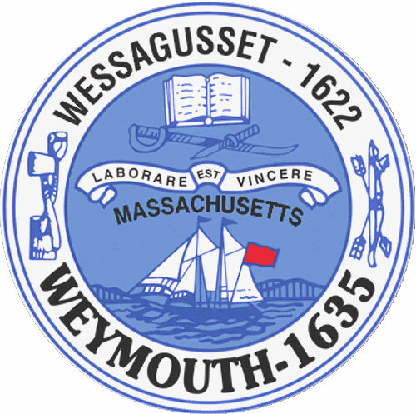

Rebecca Haugh
Thomas J. Lacey
Arthur Mathews
Brian McDonald
Michael Molisse

Town Council

Patrick O’Connor, President
Michael Smart, Vice President
Robert M. Conlon
Kenneth DiFazio
Jane Hackett
Ed Harrington

Town of Weymouth
Massachusetts

781-335-2000

781-331-5124 (TTY)

AGENDA

Budget/Management Committee Meeting
June 20, 2016
6:00PM
Council Chambers-Town Hall

Budget/Management Committee 6:00PM

Vote out the following measures for the fiscal year 2017 budget:

16 066 A -Town Council

16 066 B-Mayor’s Office

16 066 C-Reserve Fund

16 066 D-Municipal Finance

16 066 E-Town Solicitor

16 066 F-Information Services

16 066 G-Town Clerk

16 066 H-Planning and Development

16 066 I-Town Building Maintenance

16 066 J-Administrative Services-no budget for fiscal year 2017

16 066 K-Human Resources

16 066 L-Police Department

16 066 M-Fire Department

16 066 N-Licensing and Inspections

16 066 O-Department of Public Works

16 066 P-Health

16 066 Q-Library

16 066 R-Veterans’ Services

16 066 S-Parks and Recreation

16 066 T-Elder Services

16 066 U-Civil Defense

16 066 V-Commission on Disabilities

16 066 W-Youth and Family Services

16 066 X-Debt

16 066 Y-Pensions and Benefits

16 066 Z-Schools

16 066 AA-State and County Assessments

16 066 BB-Overlay for Abatements

16 066 -General Government Annual Appropriation

16 067-Revolving Accounts Annual Authorization

16 068-Gift Accounts Annual Authorization

16 069-Unpaid Bills

16 070-MTBE Settlement-FY 16 Snow Removal

16 071-Free Cash-FY16 Snow Removal

16 072-Sewer Enterprise Fund Annual Appropriation

16 073-Sewer Department-MWRA I/I Phase 9 Allocation

16 074-Sewer Retained Earnings-Capital Equipment

16 075-Water Enterprise Fund Annual Appropriation

16 076-Water Retained Earnings-Water Main Improvements

16 077-Water Retained Earnings-Capital Equipment

16 078-Water Retained Earnings-Water Treatment Plant Upgrades & Improvement

16 079- Community Preservation Committee Annual Appropriation

Mayor’s Capital Improvement Plan FY 2017

Vote out the following non-budget measures:

16 102-Special Purpose Stabilization Fund Transfer for Equipment at Pond Meadow Park

16 103-Special Purpose Stabilization Fund Transfer for Two Replacement Air Conditioning Compressors
for Tufts Library

16 104-Special Purpose Stabilization Fund Transfer for Installing Air Conditioning for the Whipple
Senior Center

16 105-Special Purpose Stabilization Fund Transfer for Repairing or Replacing Town Sidewalks

16 106-Special Purpose Stabilization Fund Transfer for a New Dump Truck with Plow for Public Works

16 107-Special Purpose Stabilization Fund Transfer for Elder Services Van

16 108-Free Cash for School Information Technology Needs

16 109-Free Cash for Two School Maintenance Vehicles

16 110-Free Cash for Curriculum Needs

16 111-Free Cash for New Police Cruisers and Motorcycles

16 112-Free Cash for a New Fire Engine

16 113-Reserve Fund Transfer to Hire a Library Building Architectural Firm

16 114-Line Item Transfer from Employee Benefits Health Insurance to Employee Benefits
-Worker’s Compensation

16 115-Free Cash for Stabilization Fund

16 116-Free Cash for OPEB Trust Fund

16 117-Borrowing Authorization for Road and Sidewalk Repairs and Reconstruction

16 118-Appointment of the Chief Financial Officer-Brian Connolly

16 119-Special Police Officer Appointment-Animal Control Officer

16 120-Appointment to the Planning Board-Paul Rotondo

16 121-Appointment to the Community Events Committee-Angela Mitchell

16 122-Reappointment to the Board of Registrars-Michele Cronin

16 123-Reappointment to the Fourth of July Committee-William Robinson

16 124-Reappointment to the Community Preservation Committee-Christopher Hannan

16 125-Reappointment to the Board of Assessors-John Sheehan

16 126-Reappointment to the Weymouth Braintree Regional Recreation Conservation District
Robert McConnell

