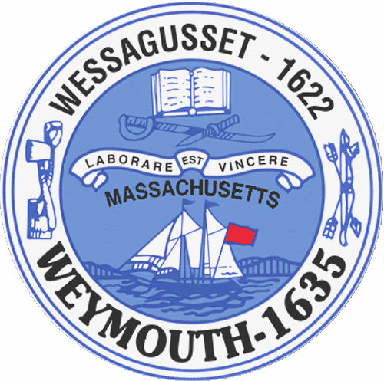

Rebecca Haugh
Thomas J. Lacey
Arthur Mathews
Brian McDonald
Michael Molisse

Town Council

Patrick O’Connor, President
Michael Smart, Vice President
Robert M. Conlon
Kenneth DiFazio
Jane Hackett
Ed Harrington

Town of Weymouth
Massachusetts

781-335-2000

781-331-5124 (TTY)

AGENDA

Budget/Management Committee Meeting
May 11, 2016
6:00 PM
Council Chambers-Town Hall

Budget/Management Committee 6:00 PM

Review and Discuss Fire Department Budget with Department Heads and Administration, Chief of Fire and applicable senior staff

Deliberate the following measure:

16 066M-Fire Department

Vote out the following measures:

16 082-Reappointment to the Board of Library Trustees-Vicki Kaufman

16 083-Reappointment to the Board of Health-Maureen DelPrete

16 084-Reappointment to the Commission on Disabilities-Gerry Begonis

