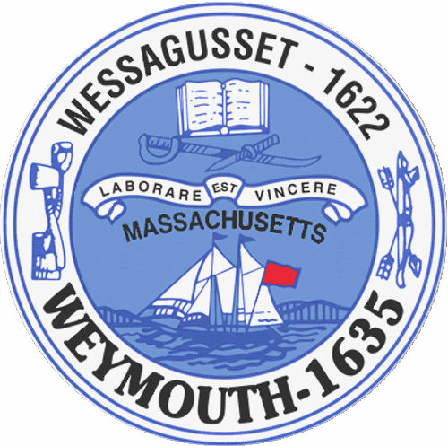

Rebecca Haugh
Thomas J. Lacey
Arthur Mathews
Brian McDonald
Michael Molisse

Town Council

Patrick O’Connor, President
Michael Smart, Vice President
Robert M. Conlon
Kenneth DiFazio
Jane Hackett
Ed Harrington

Town of Weymouth
Massachusetts

781-335-2000

781-331-5124 (TTY)

AGENDA

Budget/Management Committee Meeting
May 16, 2016
6:00 PM
Council Chambers-Town Hall

Budget/Management Committee 6:00 PM

Review and Discuss Department of Public Works, Snow Removal Measures and Water/Sewer Budgets with Department Heads and Administration, Department of Public Works Director, Water and Sewer Superintendent and Business Manager

Deliberate the following measures:

16 066O-Department of Public Works

16 070-MTBE Settlement Transfers for FY16 Snow Removal

16 071-Free Cash for FY16 Snow Removal

16 072-Sewer Enterprise Fund Annual Appropriation

16 073-Sewer Department-MWRA I/I Phase 9 Allocation

16 074-Sewer Retained Earnings-Capital Equipment

16 075-Water Enterprise Fund-Annual Appropriation

16 076-Water Retained Earnings-Water Main Improvements

16 077-Water Retained Earnings Capital Equipment

16 078-Water Retained Earnings-Water Treatment Plant Upgrades and Improvements

Vote out the following Measures:

16 087-Public Works Line Item Transfer for Parks and Playground Maintenance Overtime

16 088-Public Works Line Item Transfer for Street Painting and Recyclables

16 089-Water Enterprise Fund Line Item Transfer for Overtime

