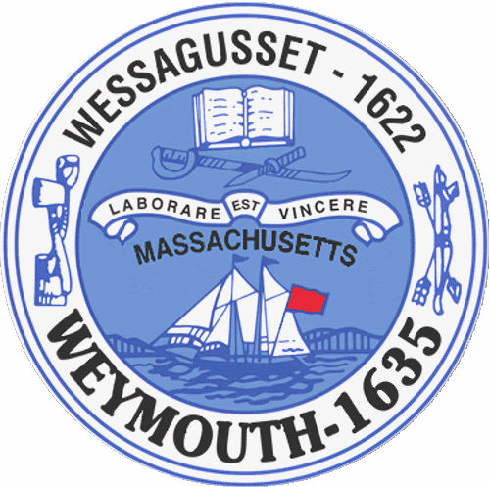

Rebecca Haugh
Thomas J. Lacey
Arthur Mathews
Brian McDonald
Michael Molisse

Town Council

Patrick O’Connor, President
Michael Smart, Vice President
Robert M. Conlon
Kenneth DiFazio
Jane Hackett
Ed Harrington

Town of Weymouth
Massachusetts

781-335-2000

781-331-5124 (TTY)

AGENDA

Budget/Management Committee Meeting
May 18, 2016
6:00 PM
Council Chambers-Town Hall

Budget/Management Committee 6:00 PM

Review and Discuss General Government Budgets with Administration and applicable Department Heads:

-Mayor’s Office
-Information Services
-Veterans’ Services
-Parks and Recreation
-Civil Defense
-Commission on Disabilities
-Youth and Family Services
-Town Solicitor
Vote out the following measures:
16 085-General Fund Reserve Appropriation for Legal expense through the
remainder FY2016

16 086-Town Solicitor’s Office Line Item Transfers

-Town Building Maintenance
-Administrative Services
-Elder Services
-Human Resources

Deliberate the following measures:

16 066B-Mayor’s Office

16 066F-Information Services

16 066R-Veterans’ Services

16 066S-Parks and Recreation

16 066U-Civil Defense

16 066V-Commission on Disabilities

16 066W-Youth and Family Services

16 066E-Town Solicitor

16 066I-Town Building Maintenance

16 066J-Administrative Services

16 066T-Elder Services

16 066K-Human Resources

