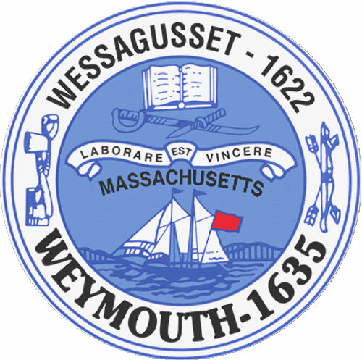

Rebecca Haugh
Thomas J. Lacey
Arthur Mathews
Brian McDonald
Michael Molisse

Town Council

Patrick O’Connor, President
Michael Smart, Vice President
Robert M. Conlon
Kenneth DiFazio
Jane Hackett
Ed Harrington

Town of Weymouth
Massachusetts

781-335-2000

781-331-5124 (TTY)

AGENDA

Budget/Management Committee Meeting
June 8, 2015
5:30 PM
Council Chambers-Town Hall

Budget/Management Committee 5:30 PM

Vote the following measures:

15 072-CPC-Preservation of Weymouth Libraries’ Historical Collections

15 086-Pensions and Benefits Line Item Transfer Part 2

Review and Discuss School Department Budget with School Superintendent, Assistant Superintendents and Senior Staff

Deliberate the following measures:

15 051Z-School Department

15 057-Free Cash-SPED Out-Of-District Tuition

