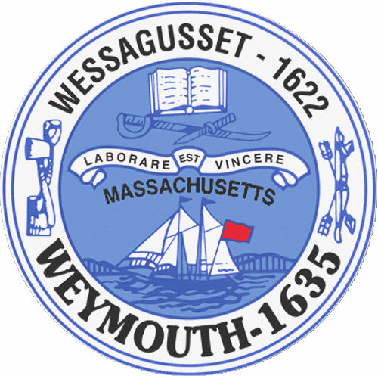

Rebecca Haugh
Thomas J. Lacey
Arthur Mathews
Brian McDonald
Michael Molisse

Town Council

Patrick O’Connor, President
Michael Smart, Vice President
Robert M. Conlon
Kenneth DiFazio
Jane Hackett
Ed Harrington

Town of Weymouth
Massachusetts

781-335-2000

781-331-5124 (TTY)

AGENDA

Budget/Management Committee Meeting
June 15, 2015
6:00 PM
Council Chambers-Town Hall

Budget/Management Committee 6:00 PM

Vote out the following measures for the fiscal year 2016 budget:

15 051 A -Town Council

15 051 B-Mayor’s Office

15 051 C-Reserve Fund

15 051 D-Municipal Finance

15 051 E-Town Solicitor

15 051 F-Information Services

15 051 G-Town Clerk

15 051 H-Planning and Development

15 051 I-Town Building Maintenance

15 051 J-Administrative Services

15 051 K-Human Resources

15 051 L-Police Department

15051 M-Fire Department

15 051 N-Licensing and Inspections

15 051 O-Department of Public Works

15 051 P-Health

15 051 Q-Library

15 051 R-Veterans’ Services

15 051 S-Parks and Recreation

15 051 T-Elder Services

15 051 U-Civil Defense

15 051 V-Commission on Disabilities

15 051 W-Youth and Family Services

15 051 X-Debt

15 051 Y-Pensions and Benefits

15 051 Z-Schools

15 051 AA-State and County Assessments

15 051 BB-Overlay for Abatements

15 051-General Government Annual Appropriation

15 052-Revolving Accounts Annual Authorization

15 053-Gift Accounts Annual Authorization

15 054-Unpaid Bills

15 055-MTBE Settlement-FY 15 Snow Removal Appropriation

15 056-Free Cash-FY15 Snow Removal Appropriation

15 057-Free Cash-SPED Out-Of-District Tuition

15 058-Free Cash-Fy16 53rd Week of Payroll

15 059-Sewer Enterprise Fund Annual Appropriation

15 060-Sewer Department-MWRA I/I Phase 8 Allocation

15 061-Sewer Retained Earnings-Pump Station Improvements

15 062-Sewer Retained Earnings-Capital Equipment

15 063-Sewer Capital Projects-Transfer Unexpended Balances to Capital
Projects Residuals

15 064-Water Enterprise Fund Annual Appropriation

15 065-Water Retained Earnings-Water Main Improvements

15 066-Water Retained Earnings-Capital Equipment

15 067-Water Retained Earnings-AJB WTP & Well Improvements

15 068-Water Capital Projects-Transfer Unexpended Balances to Capital
Projects Residuals

15 069-Community Preservation Committee Annual Appropriation

Issue-Capital Improvement Plan FY 2016

Vote out the following non-budget measure:

15 087-Reappointment to the Board of Registrars-Kenneth Karlberg

