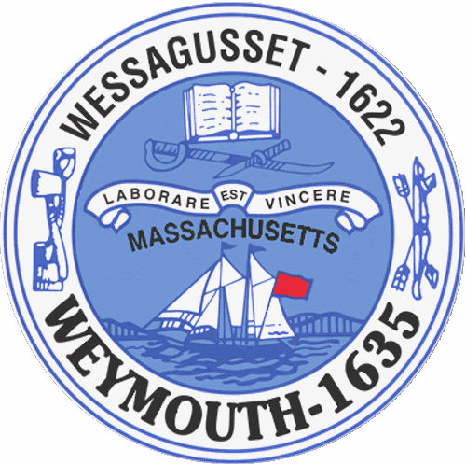

Rebecca Haugh
Thomas J. Lacey
Arthur Mathews
Brian McDonald
Michael Molisse

Town Council

Patrick O’Connor, President
Michael Smart, Vice President
Robert M. Conlon
Kenneth DiFazio
Jane Hackett
Ed Harrington

Town of Weymouth
Massachusetts

781-335-2000

781-331-5124 (TTY)

AGENDA

Mental Health and Substance Abuse Committee
May 16, 2016
5:00 PM
Council Chambers-Town Hall

Mental Health and Substance Abuse Committee 5:00 PM

D.A.R.T. “Drug Addiction Resource Team”-Community Outreach Services update by the Weymouth Police Department
-Councilor Thomas J. Lacey

