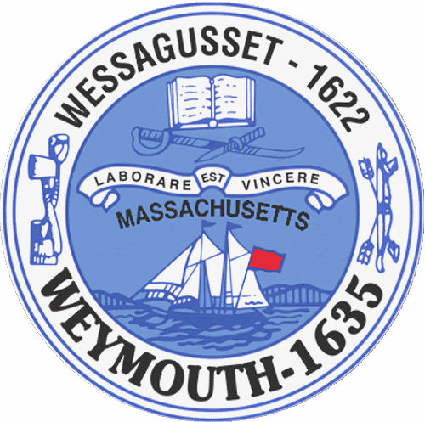

Fred Happel, Jr.
Christopher Heffernan
Maureen Kiely
Gary MacDougall
Greg Shanahan

Town Council

Arthur Mathews, President
Michael Molisse, Vice President

John Abbott
Lisa Belmarsh
Pascale Burga
Kenneth DiFazio

Town of Weymouth
Massachusetts

781-335-2000

781-331-5124 (TTY)

AGENDA

Budget/Management Committee

July 31, 2023

7:00 PM

Town Council Chambers

23 110-CPA Request-Historic Map Restoration
23 090-Free Cash for Riley Field Pickleball Courts
16 101-Legal Counsel Representation for Town Council

