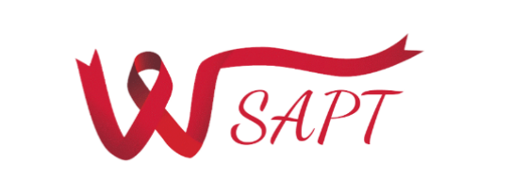

Weymouth Substance Abuse Prevention Team
Wednesday January 18, 2023 4:00 PM – Hybrid Meeting
Tufts Library Room 138
Click Here for Zoom Meeting
AGENDA
Item | Content | Time Needed
Welcome/Introductions | - Housekeeping  - Group Agreements | 10 minutes
Opioid Abatement Updates | - Opioid Abatement Update  - Spending Guidelines  - Planning Focus Groups  - Request for Funding | 40 minutes
Announcements/Other Business | Other announcements, discussion, and updates | 10 minutes
Next Meeting: February 8, 2023 | SAPT Updates! | In-Person

UPDATED Mission Statement: The Weymouth Substance Abuse Prevention Team is a group of community members and professional contributors working together to reduce the impact of substance misuse by providing resources and education that promote safety, health, and
wellness for all of Weymouth’s residents.

