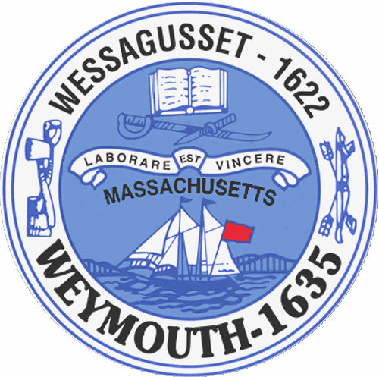

Rebecca Haugh
Thomas J. Lacey
Arthur Mathews
Brian McDonald
Michael Molisse

Town Council

Patrick O’Connor, President
Michael Smart, Vice President
Robert M. Conlon
Kenneth DiFazio
Jane Hackett
Ed Harrington

Town of Weymouth
Massachusetts

781-335-2000

781-331-5124 (TTY)

AGENDA

Budget/Management Committee Meeting

May 2, 2016
6:00 PM
Council Chambers-Town Hall

Budget/Management Committee 6:00 PM

Budget Kick-Off Meeting

Review/discuss revenues, reserve fund, overlay for abatements, debt, pensions, benefits, revolving
and gift donation accounts, local aid and state assessments as well as unpaid bills.

Deliberate the following measures:

16 066-General Government Annual Appropriation

16 066C-Reserve Fund

16 066BB-Overlay for Abatements

16 066X-Debt

16 066Y-Pensions and Benefits

16 067-Revolving Accounts Annual Authorization

16 068-Gift Accounts Annual Authorization

16 066AA-State and County Assessments

16 069-Unpaid Bills

