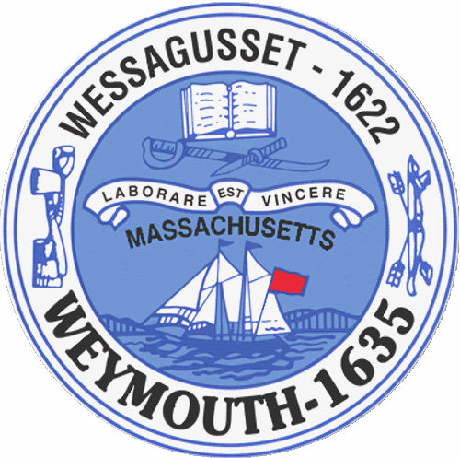

Rebecca Haugh
Thomas J. Lacey
Arthur Mathews
Brian McDonald
Michael Molisse

Town Council

Patrick O’Connor, President
Michael Smart, Vice President
Robert M. Conlon
Kenneth DiFazio
Jane Hackett
Ed Harrington

Town of Weymouth
Massachusetts

781-335-2000

781-331-5124 (TTY)

AGENDA

Ordinance Committee Meeting
February 1, 2016
6:15 PM
Council Chambers-Town Hall

Ordinance Committee 6:15 PM

- 006 - Ordinance Amendment- Chapter 7

- 002 - Rezone request for 1081 Washington Street (Map 34,Block 402, Lot 11) From
Residential (R1) to Limited Business (B1) submitted by Carl Kelso

