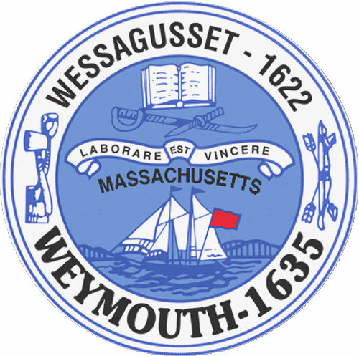

Rebecca Haugh
Thomas J. Lacey
Arthur Mathews
Brian McDonald
Michael Molisse

TOWN COUNCIL

Patrick O’Connor, President
Michael Smart, Vice President
Robert M. Conlon
Kenneth DiFazio
Jane Hackett
Ed Harrington

Town of Weymouth
Massachusetts

781-335-2000

781-331-5124 (TTY)

AGENDA

Special Town Council Meeting

June 8, 2015
7:30 PM
Council Chambers-Town Hall

- PLEDGE OF ALLEGIANCE

- ROLL CALL

- ANNOUNCEMENTS

- PUBLIC HEARINGS

7:35PM 15 076-Proposition 2 ½ Override
Continued Public Hearing from 5/18/15, 5/26/15 and 6/1/15

- OLD BUSINESS

15 076 –Proposition 2 ½ Override

- COMMUNICATIONS AND REPORTS FROM MAYOR, TOWN OFFICERS AND TOWN BOARDS

- ADJOURNMENT

The next Town Council Meeting will be held June 15, 2015 at 7:30 PM
Sign up for E-Alerts to receive agendas, minutes & other announcements at www.weymouth.ma.us.

