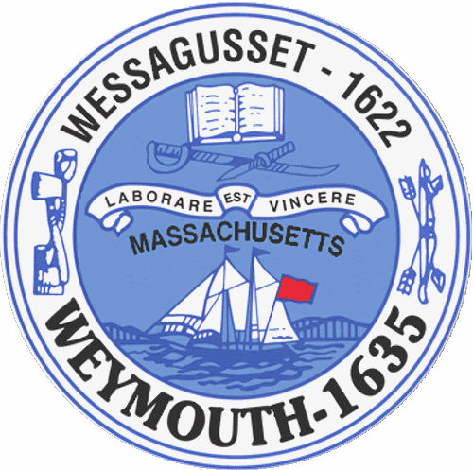

Rebecca Haugh
Thomas J. Lacey
Arthur Mathews
Brian McDonald
Michael Molisse

Town Council

Patrick O’Connor, President
Michael Smart, Vice President
Robert M. Conlon
Kenneth DiFazio
Jane Hackett
Ed Harrington

Town of Weymouth
Massachusetts

781-335-2000

781-331-5124 (TTY)

AGENDA

Budget/Management Committee Meeting

June 6, 2016
6:00 PM
Council Chambers-Town Hall

Budget/Management Committee 6:00 PM

Vote out the following Measures:

16 093-Appointment/Contract of Town Auditor

16 096-Reappointment to Veteran’s Council-Robert Haley

16 097-Reappointment to the Board of Assessors-Kevin Spellman

16 098-Historic Commission Line Item Transfer for Repairs to Civil War Monument

16 099-Fire Department Line Item Transfer for Engine 5 Repairs

16 100-Special Purpose Stabilization Fund-Peer Review of 2008 Columbian Square
Conceptual Plans and Design

16 016-Contract for Independent Audit-FY16 through FY18

