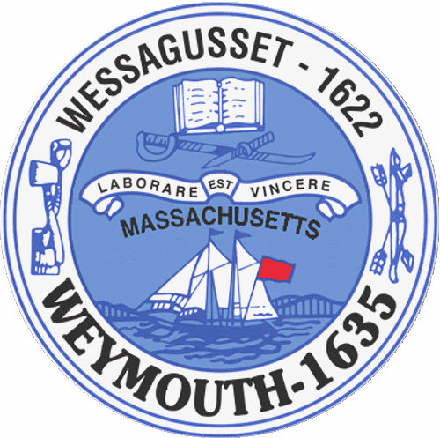

Rebecca Haugh
Thomas J. Lacey
Arthur Mathews
Brian McDonald
Michael Molisse

Town Council

Patrick O’Connor, President
Michael Smart, Vice President
Robert M. Conlon
Kenneth DiFazio
Jane Hackett
Ed Harrington

Town of Weymouth
Massachusetts

781-335-2000

781-331-5124 (TTY)

AGENDA

Budget/Management Committee Meeting
May 23, 2016
6:00 PM
Council Chambers-Town Hall

Budget/Management Committee 6:00 PM

Review and discuss General Government Budgets with Chief Financial Officer and applicable Department
Heads:

-Municipal Finance
-Capital Improvement Plan
-Planning and Development
-Licensing and Inspections
-Community Preservation Committee
-Town Council
-Town Clerk
-Health
-Library

Deliberate the following measures:

16 066D-Municipal Finance

Capital Improvement Plan

16 066H-Planning and Development

16 066N-Licensing and Inspections

16 079-Community Preservation Committee Annual Appropriation

16 066A-Town Council

16 066G-Town Clerk

16 066P-Health

16 066Q-Library

