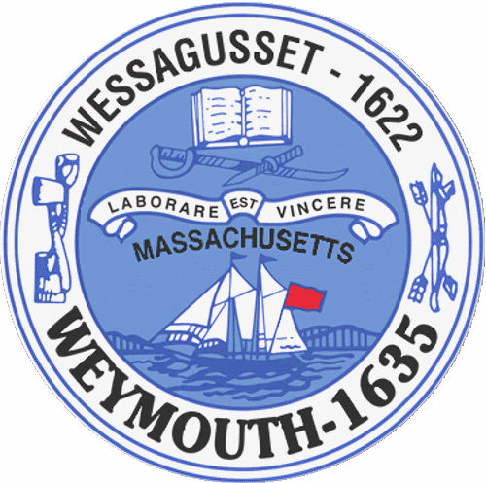

Rebecca Haugh
Thomas J. Lacey
Arthur Mathews
Brian McDonald
Michael Molisse

Town Council

Patrick O’Connor, President
Michael Smart, Vice President
Robert M. Conlon
Kenneth DiFazio
Jane Hackett
Ed Harrington

Town of Weymouth
Massachusetts

781-335-2000

781-331-5124 (TTY)

AGENDA

Budget/Management Committee Meeting
June 1, 2016
6:00 PM
Council Chambers-Town Hall

Budget/Management Committee 6:00 PM

Review and Discuss School Department Budget with School Superintendent, Assistant Superintendents
and Senior Staff

Deliberate the following measure:

16 066Z-School Department

