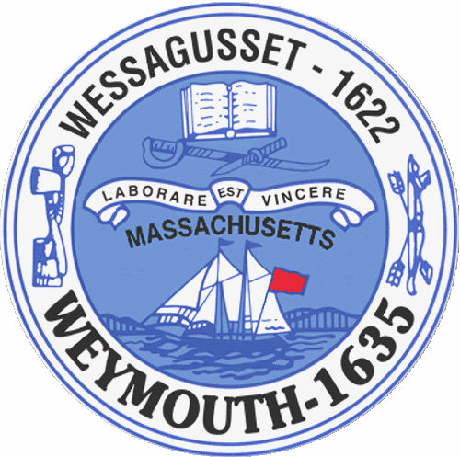

Rebecca Haugh
Thomas J. Lacey
Arthur Mathews
Brian McDonald
Michael Molisse

Town Council

Patrick O’Connor, President
Michael Smart, Vice President
Robert M. Conlon
Kenneth DiFazio
Jane Hackett
Ed Harrington

Town of Weymouth
Massachusetts

781-335-2000

781-331-5124 (TTY)

AGENDA

Budget/Management Committee Meeting
May 26, 2015
5:45 PM
Council Chambers-Town Hall

Budget/Management Committee 5:45 PM

Review and discuss General Government Budgets with Chief Financial Officer and applicable Department
Heads:

-Municipal Finance
-Planning and Development
-Licensing and Inspections
-Community Preservation Committee
-Town Council
-Town Clerk
-Health
-Library

Deliberate the following measures:

15 051D-Municipal Finance

Capital Improvement Plan

15 070-Debt Refinancing

15 071-Bonding for Various Capital Projects

15 051H-Planning and Development

15 051N-Licensing and Inspections

15 069-Community Preservation Committee Annual Appropriation

15 051A-Town Council

15 051G-Town Clerk

15 051P-Health

15 051Q-Library

Vote the following measures:

15 072-CPC –Preservation of Weymouth Libraries’ Historical Collections

15 073-CDBG Authorization 2015-2016

15 079-Reappointment to the Board of Library Trustees-Dorothy Coveney

15 080-Reappointment to the Waterfront Committee-Raymond Nash

15 081-Reappointment to the Local Emergency Planning Committee-Jonathan Tose

15 082-Pensions and Benefits Line Item Transfer

15 083-RFT-Administrative Services

15 084-RFT-Fire Department Overtime

15 085-RFT-Water Enterprise Overtime

