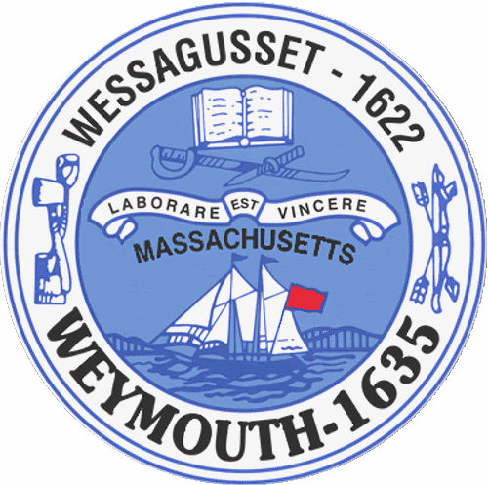

Rebecca Haugh
Thomas J. Lacey
Arthur Mathews
Brian McDonald
Michael Molisse

Town Council

Patrick O’Connor, President
Michael Smart, Vice President
Robert M. Conlon
Kenneth DiFazio
Jane Hackett
Ed Harrington

Town of Weymouth
Massachusetts

781-335-2000

781-331-5124 (TTY)

AGENDA

Budget/Management Committee Meeting
May 4, 2016
6:00 PM
Council Chambers-Town Hall

Budget/Management Committee 6:00 PM

Review and Discuss Police Department Budget with Department Heads and Administration, Chief of Police and Applicable Senior Staff

Deliberate the following measure:

16 066L-Police Department

