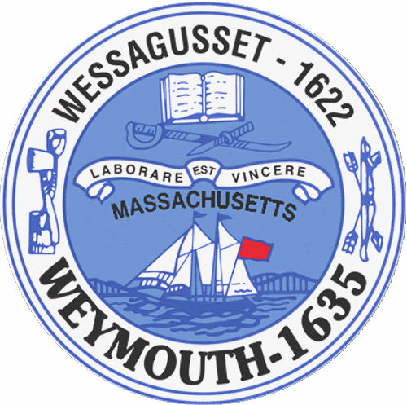

Rebecca Haugh
Christopher Heffernan Thomas J. Lacey
Brian McDonald
Michael Molisse

Town Council

Michael Smart, President
Arthur Mathews, Vice President

Kenneth DiFazio
Jane Hackett
Fred Happel, Jr.
Ed Harrington

Town of Weymouth
Massachusetts

781-335-2000

781-331-5124 (TTY)

AGENDA

Budget/Management Committee Meeting
January 16, 2018
6:00PM
Council Chambers-Town Hall

Budget/Management Committee 6:00PM

17 110-Acceptance of G.L. C.71,s.37M-Consolidation of Administrative Functions

17 124-CPA Funding Request for Stella Tirrell Park

17 128-Establishment of the Department of Asset Management and Procurement

